 Methods Unit 3 Test 3, 2018

(Calculator Free) Name__________________

Time: 20 minutes Marks: 20

Show working in sufficient detail to support your answers. Incorrect answers given without supporting reasoning may not be allocated any marks.

1. [2, 2, 2 marks]

Determine $\frac{dy}{dx}$ in terms of x, for the following (you do not need to simplify):

a) y = e2-3x . cos (2x -1)

$\frac{dy}{dx}$ = -3e2-3x.cos(2x - 1) + e2-3x.[ -2sin(2x – 1)]

b) y = $\frac{sin⁡(x)-cos⁡(x)}{4cos⁡(x)}$

= ¼ tan(x) – ¼

$\frac{dy}{dx}$ = $\frac{\tan^{2}\left(x\right)+1}{4}$

c) y = sin(4x) – cos2(1 – 4x)

= 4cos(4x) - 8 cos(1 - 4x). sin(1 – 4x)

1. [2, 2 marks]

Determine the following indefinite integrals:

a)

= - ½ cos3(2x) + c

b)

=

= -1/5 cos (5x) + c

[4 marks]

Evaluate $\int_{\frac{π}{4}}^{\frac{π}{2}}{ 3 CosX}SinX dx$

$\left[\frac{3\sin^{2}(x)}{2}\right]\begin{matrix}\frac{π}{2} \\ \frac{π}{4}\end{matrix}$

= $\frac{3{(1)}^{2}}{2}$- $\frac{3{\frac{\sqrt{2}}{2}}^{2}}{2}$

= 1.5 – 0.75

= 0.75

4. [4, 2 marks]

Consider the Discrete Random Variable X defined by the table below.

|  |  |  |  |  |  |
| --- | --- | --- | --- | --- | --- |
| x | 1 | 2 | 3 | 4 | 5 |
| P(X = x) | a | 0.15 | b | 0.15 | 0.2 |

a) Given E[X] = 2.8, determine a and b.

a + b = 0.5

a + 3b = 0.9

2b = 0.4 $⟹$ b = 0.2

a = 0.3

b) Determine P(X < 4|X $≥$ 2)

$\frac{0.35}{0.7}$ = 0.5



Methods Unit 3 Test 3, 2018

(Calculator Assumed) Name___________________

Time: 40 minutes Marks: 40

Show working in sufficient detail to support your answers. Incorrect answers given without supporting reasoning may not be allocated any marks.

5. [5 marks]

Given that 0< x < $π$, determine the exact coordinates of the point(s) on the curve y = 2 sin (x – 1) where the gradient is 1.

$\frac{dy}{dx}$ = 2 cos(x – 1) = 1

cos (x – 1) = ½

x – 1 = $\frac{π}{3}$

x = $\frac{π}{3}$ + 1

y = 2 sin $\frac{π}{3}$ = $\sqrt{3}$

The required coordinate is ( + 1, )

6. [6 marks]

The probability distribution for a discrete random variable is

f(x) = $\left[\begin{matrix}\frac{2-x}{k+1} for x=0, 1 \\ 0 for all other values of x\end{matrix}\right.$

Determine k, and hence determine E[X] and StDev[X].

+ = 1

$\frac{3}{k+1}$ = 1

Thus k = 2

|  |  |  |
| --- | --- | --- |
| x | 0 | 1 |
| P(X = x) | 2/3 | 1/3 |

E[X] = 1/3

SD[X] = 0.4714 or $\sqrt{2/9}$

1. [2, 1, 2, 3, 3 marks]

An avocado grower regularly sells fruit to supermarkets, and each avocado is checked for size before transporting. It is found that 1 in every 8 avocados is rejected as too small.

A box of 50 avocados is ready to be checked.

What is the probability that

a) at least five avocados will be rejected?

X $\sim$ bin(50, 0.125)

P(X $≥$ 5) = 0.7654

b) one avocado will be rejected?

P(X = 1) = 0.0090

c) no more than five avocados are rejected, given at least one is rejected?

$\frac{0.3922}{0.9987}$

= 0.3927

d) The probability that a box of avocados are all correct size (no rejects) is approximately 0.07. How many avocados in the box?

(0.875)n (0.125)0 = 0.07

n = 19.9

There are 20 in the box.

e) The grower selects five avocados.

i) What is the probability that exactly one is too small?

5 x (0.875)4 (0.125)1

= 0.3664

ii) What is the probability that at least one is too small?

1 – 0.8755 = 0.4871

8. [3, 4 marks]

A game is played at a football club fundraising event. Each player pays $2 per game.

Two dice are rolled and the uppermost faces are added. If the result is a total of 2 or 12, the player receives $10. If the result is a total of 7, the player receives $5. Otherwise, no prize is awarded.

a) Determine how much the club would expect to raise after playing 100 games.

|  |  |  |  |
| --- | --- | --- | --- |
| x | -8 | -3 | 2 |
| P(X = x) | 1/18 | 1/6 | 7/9 |

E[X] = 0.61111

0.6111 X 100 = $61.11

b) What is the maximum amount that could be paid for “2 or 12” (instead of $10) and not make a loss on the game?

|  |  |  |  |
| --- | --- | --- | --- |
| x | a + 2 | -3 | 2 |
| P(X = x) | 1/18 | 1/6 | 7/9 |

$\frac{a+2}{18}- \frac{9}{18}+ \frac{28}{18}$ = 0

` a + 2 – 9 + 28 = 0

a = -21

They could pay $21 and break even.

9. [4 marks]

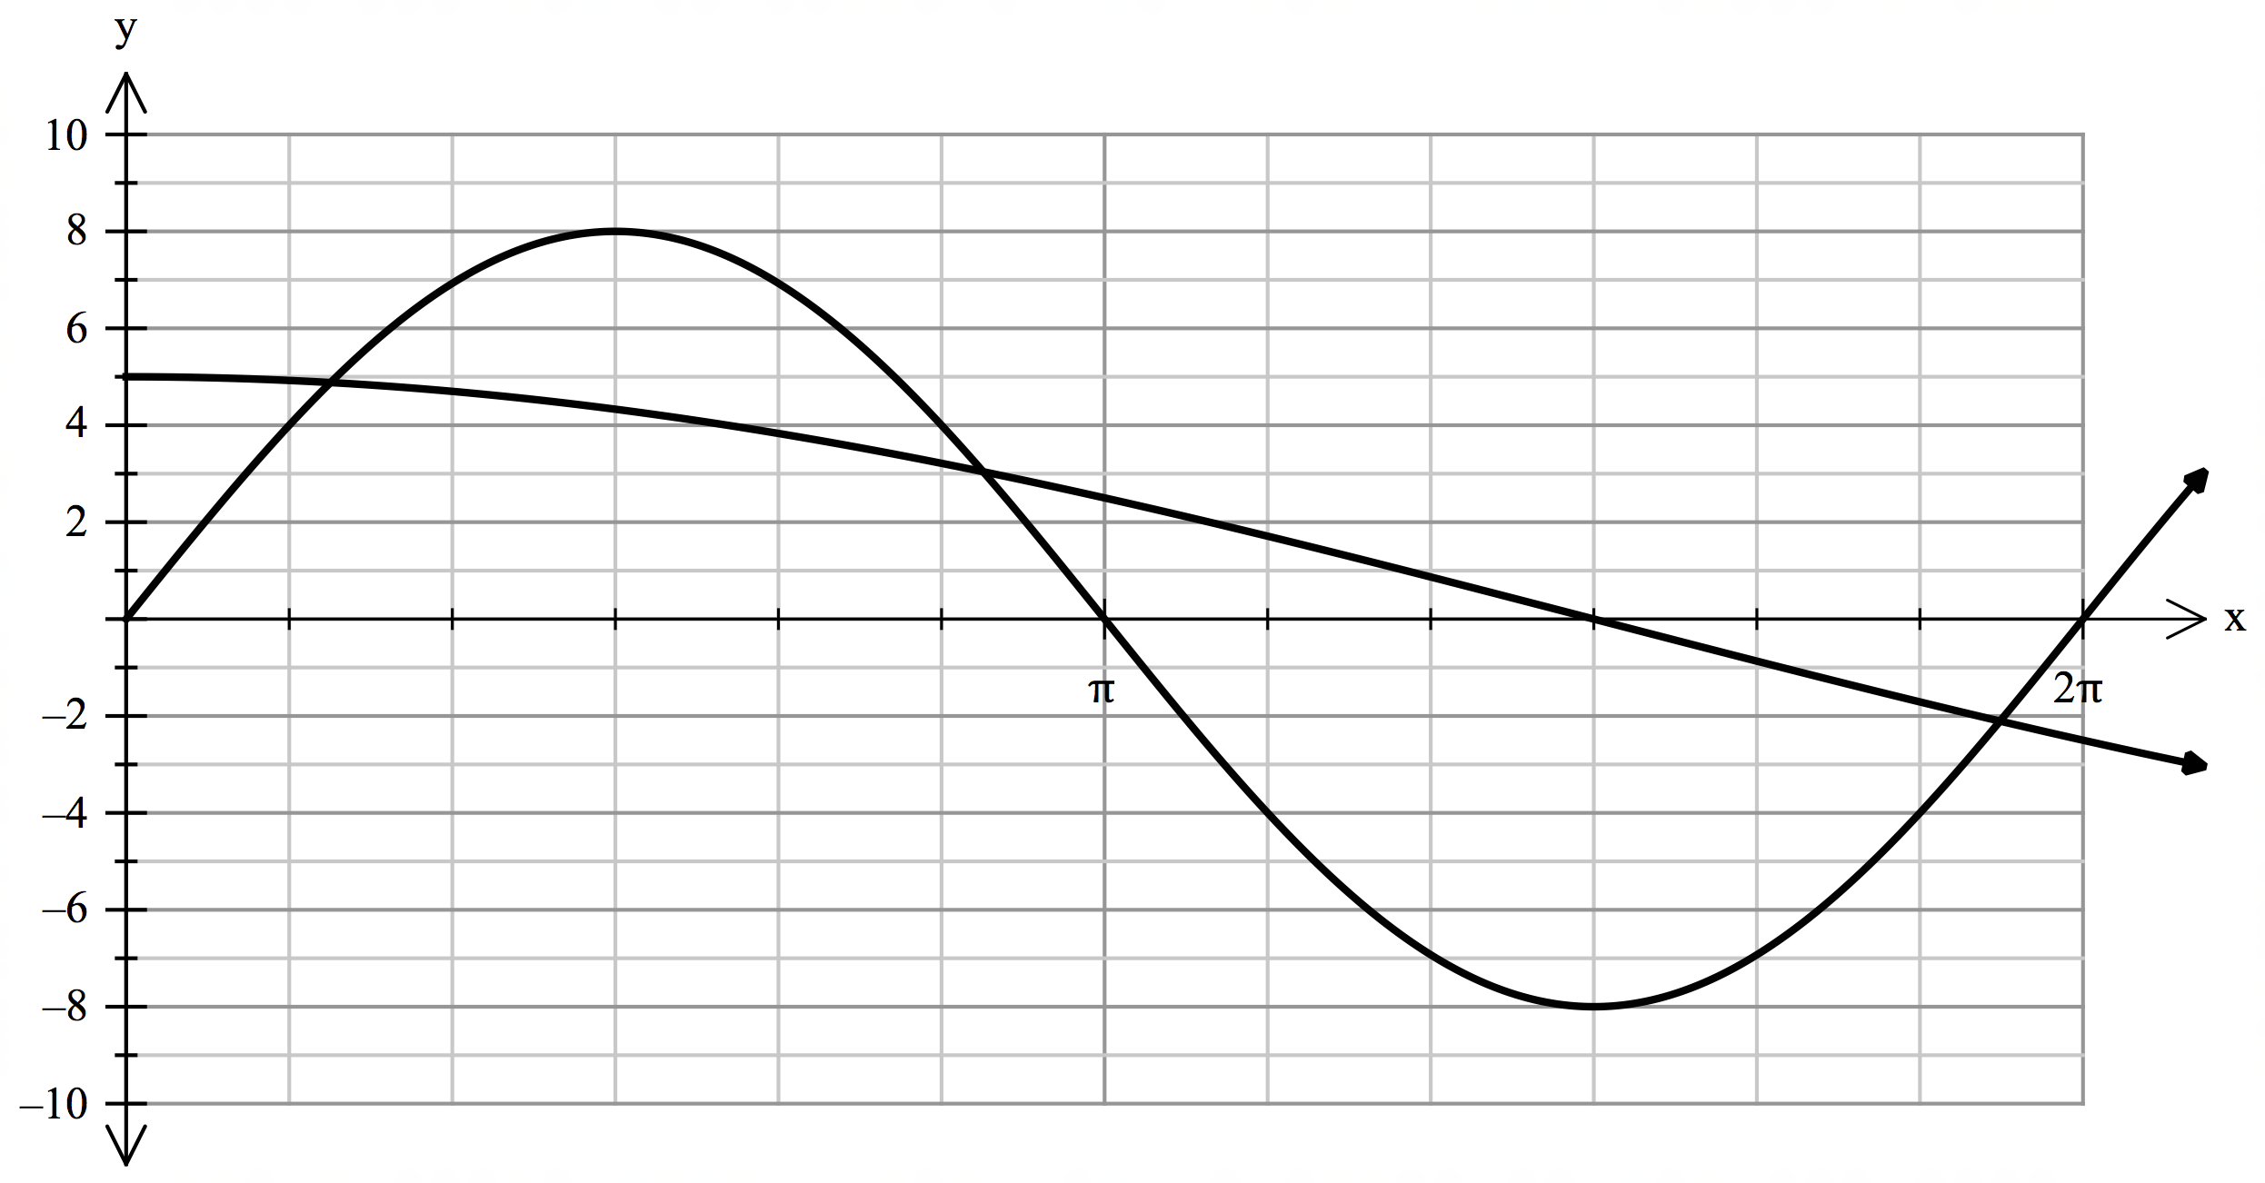

Determine, using calculus techniques, the approximate area between y = 8 sin(x) and y = 5 cos( $\frac{x}{3}$), as illustrated above. Round your answer to 1 decimal place.

Points of intersection @ x = 0.6562, x = 2.7518, x = 6.0168

$\int_{0.6562}^{6.0168}{\left|8\sin\left(x\right)-5 cos( \frac{x}{3} )\right|}$

= 21.9 units2

10. [1, 2, 2, 2 marks]

For a particular binomial distribution where X $\sim$ bin(20, *p*), the mean is 7.

a) Determine *p.*

0.35

b) Determine the standard deviation.

$\sqrt{0.35.0.65}$

= 0.4770

c) Determine E [5 – 2X]

5 – 2 x 7

= -9

d) Determine Var [5 - 2X]

(-2)2.(0.4770)

= 1.91